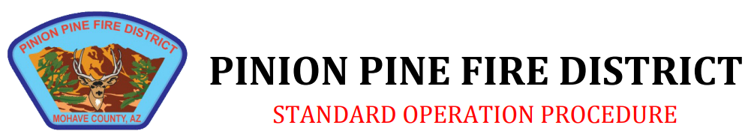

Policy Title: Seat Belt Usage

Policy Number: 345.10 |  | Created: 3/23
Section: Operations Response |  | Revised:3/23

Purpose: The purpose of this policy is to define a policy for the use of seatbelts by department personnel while riding in or operating fire apparatus, staff, and city vehicles.
It shall serve to assure that the Pinion Pine Fire Department is in compliance with adopted
standards, statutes, regulations, and laws.

Scope: Responding to an emergency incident does not in any manner reduce the responsibility to operate vehicles safely. While prompt response to emergency incidents is an organizational priority, safety is always a higher priority. The responding units must arrive safely at the location where they are needed before they can deliver the required services. Unsafe operation of an emergency vehicle creates an unacceptable risk to Fire Department personnel, to the public, and to the individuals who are in need of assistance.
It shall be the responsibility of the Company Officer/Shift Leader to assure that all units/personnel under their command are familiar with and adhere to this operating procedure.
The driver of a fire apparatus is responsible for the safe operation of the vehicle at all times,
including compliance with all traffic laws as well as Pinion Pine Fire Department policies and procedures.

The company officer in charge of a fire apparatus is responsible for supervising the driver and all other assigned personnel; this includes assuring that the driver complies with all traffic laws as well as Pinion Pine Fire Department policies, procedures, and SOP’s.
The use of seat belts while in a department vehicle is mandatory at all times. No person shall stand in the cab or don personnel protective equipment (PPE) while the apparatus/vehicle is in motion.

Any person operating or riding in a department vehicle is required to properly secure the safety belt(s) before the vehicle begins to move. The driver shall not begin to move the vehicle until all passengers are seated and properly secured. All passengers shall remain seated and secured as long as the vehicle is in motion. Seatbelts shall not be loosened or released while en-route to dress or don equipment.
Members shall not attempt to mount or dismount from a moving vehicle under any
circumstances. Personnel riding in other vehicles while on duty shall also use safety belt(s).

