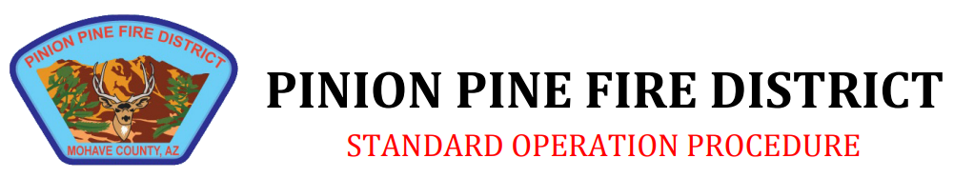

Policy Title: Swift Water Response

Policy Number: 340.10 |  | Created: 4/23
Section: Operations |  | Revised: 4/23

Purpose: To ensure the safe and proper response to incidents that involve swift water rescue deployments

Scope: It is the policy of the Pinion Pine Fire Department to refer all calls for service in the realm of swift water rescue response to the agency of Mohave County Search and Rescue. However, in the event of an in district swift water response the following guidance should be followed:

- All personnel on the scene of a swift water emergency will wear a PFD (personal floatation device) if within 20 feet of the water level. PPFD PFDs will be equipped with an audio and visual device (emergency whistle and strobe light) to be used if the rescuer finds themselves in need of assistance.
- Under no circumstances will firefighter turnout gear be worn during a swift water emergency response.
- Under the judgment of the incident commander, if a victim can be given a PFD via the means of a rope bag throw, pike pole, ect, then an effort should be made to do so.
- In the event of a victim in the water, and an immediate rescue can be attempted via rope bag, then the incident commander should direct rope bag deployment at the location of the victim with a second responder located 20 feet downstream of their current location if the initial rescue throw fails. Rescuers should remain in contact with one another via line of sight.
- AMR should be notified immediately on all swift water response reports
- Under no circumstances should any personnel direct a victim to tie a rescue rope around themselves during a rescue.

